**Aryabhatta Knowledge University**

## Patna, Bihar 800001



**2020-21**

**A Project Report on**

### Hostel Management System

Submitted in partial fulfillment of the requirements for the award of degree

**BACHELOR OF TECHNOLOGY IN**

**COMPUTER SCIENCE & ENGINEERING**

**By**

|  |  |  |
| --- | --- | --- |
| **PRINCE KUMAR PATEL** | **-** | **18105108907** |
| **SURAJ ANAND** | **-** | **18105108905** |
| **KAUSHAL RANJAN** | **-** | **18105108906** |

#### Under the esteemed guidance of Prof. GAURAV KUMAR

**Assistant Professor Department of CSE**

**Bhagalpur College of Engineering, Bhagalpur**



Department of Computer Science & Engineering

**Bhagalpur College of Engineering, Bhagalpur**

**Aryabhatta Knowledge University**

Patna, Bihar 800001

Department of Computer Science & Engineering

**Bhagalpur College of Engineering, Bhagalpur**



**CERTIFICATE**

This is to certify that the project entitled “HOSTEL MANAGEMENT SYSTEM” had carried out by PRINCE KUMAR PATEL(18105108907), SURAJ ANAND(18105108905), KAUSHAL RANJAN(18105108906) in partial fulfillment of the requirements for the award of degree of Bachelor of Technology in Computer Science and Engineering of Aryabhatta Knowledge University, Patna during the academic year 2020-21. It is certified that all corrections/suggestions indicated for Internal Assessment have been incorporated in Report deposited in departmental library. The project has been approved as it satisfies the academic requirements in respect of Project work prescribed for the Bachelor of Technology Degree.

#### Project Guide

Prof. Gaurav Kumar Asst. Prof. Dept. of CSE B.C.E, Bhagalpur

Prof. Raj Anwit

Head of Dept. of CSE B.C.E, Bhagalpur

Name of Examiners Signature with Date

**Aryabhatta Knowledge University**

Patna, Bihar 800001

Department of Computer Science & Engineering

**Bhagalpur College of Engineering, Bhagalpur**

**DECLARATION**

We, PRINCE KUMAR PATEL(18105108907),SURAJ ANAND(18105108905), KAUSHAL RANJAN(18105108906) Student of Seventh Semester Bachelor of Technology, in the Department of Computer Science & Engineering, Bhagalpur College of Engineering, Bhagalpur declare that the project entitled “HOSTEL MANAGEMENT SYSTEM” had carried out by us and submitted partial fulfillment of the course requirements for the award of degree of Bachelor of Technology in Computer Science and Engineering of Aryabhatta Knowledge University, Patna during the academic year 2020- 21.

PRINCE KUMAR PATEL(18105108907) SURAJ ANAND(18105108905) KAUSHAL RANJAN(18105108906)

## ACKNOWLEDGEMENT

The satisfaction that accompanies that the successful completion of any task would be incomplete without the mention of people whose ceaseless cooperation made it possible, whose constant guidance and encouragement crown all efforts with success.

We are grateful to our project guide Prof. Gaurav Kumar for the guidance, inspiration and constructive suggestions that helps me in the preparation of this project.

PRINCE KUMAR PATEL(18105108907)

SURAJ ANAND(18105108905)

KAUSHAL RANJAN(18105108906)

## ABSTRACT

“HOSTEL MANAGEMENT SYSTEM” is software developed for managing various activities in the hostel. For the past few years the numbers of educational institutions are increasing rapidly. Thereby the numbers of hostels are also increasing for the accommodation of the students studying in this institution. And hence there is a lot of strain on the person who are running the hostel and software’s are not usually used in this context. This particular project deals with the problems on managing a hostel and avoids the problems which occur when carried manually. Identification of the drawbacks of the existing system leads to the designing of computerized system that will be compatible to the existing system with the system which is more users friendly and more GUI oriented.

## TABLE OF CONTENT

|  |  |
| --- | --- |
|  | **Page Number** |
| **I) ACKNOWLEDEGEMENT** | 4 |
| **II) ABSTRACT** | 5 |
| **1. INTRODUCTION** | **7** |
| 1.1 PROBLEM DEFINITION | 7 |
| 1.2 OBJECTIVES OF PROJECT | 7 |
| **2. SYSTEM ENVIRONMENT** | 8 |
| 2.1 HARDWARE CONFIGURATION | 8 |
| 2.2 SOFTWARE CONFIGURATION | 8 |
| **3. SYSTEM ANALYSIS** | 9 |
| 3.1 EXISTING SYSTEM | 9 |
| 3.2 PROPOSED SYSTEM | 9 |
| 3.3 SOFTWARE TOOL USED | 10-11 |
| **4. CODES AND OUTPUTS** | 12 |
| 4.1 ADMIN.PHP  4.2 INDEX.PHP  4.3 STUDENT_HEAD.PHP  4.4 LOGIN.PHP  4.5 ADMIN_HEAD.PHP  4.6 PROFILE.PHP | 12-13  14-15  16-19  20-23  24-27  28-32 |
| **5. DATABASES**  **6. CONCLUSION** | 33-38  39 |

1. **INTRODUCTION**
   1. **PROBLEM DEFINITION**

This system is designed in favor of the hostel management which helps them to save the records of the students about their rooms and other things. It helps them from the manual work from which it is very difficult to find the record of the students and the mess bills of the students, and the information of about the those ones who had left the hostel. All the hostels at present are managed manually by the hostel office. The Registration form verification to the different data processing is done manually. Thus there are a lot of repetitions which can be easily avoided. And hence there is a lot of strain on the person who are running the hostel and software’s are not usually used in this context. This particular project deals with the problems on managing a hostel and avoids the problems which occur when carried manually Identification of the drawbacks of the existing system leads to the designing of computerized system that will be compatible to the existing system with the system which is more user friendly. We can improve the efficiency of the system, thus overcome the drawbacks of the existing system. We design this system of the hostel management especially for the college hostel, through this they cannot require so efficient person to handle and calculate the things. This system automatically calculates all the bills and issued the notifications for those students who are against some rules.

#### OBJECTIVESOF PROJECT

This software product the hostel management to improve their services for all the students of the hostel. This also reduce the manual work of the persons in admin panel and the bundle of registers that were search when to find the information of a previous student, because through this system you can store the data of those students who had left the hostel . Through this you can check the personal profile of all the current students within few minutes the database of the system will help you to check a particular one. The system will help you to check the mess bills of every student and the student’s hostel dues. The students of the hostel will be recognized from the ID number allocated at the room rental time. In the last this system will improve the management work in the hostel.

* To automate each and every activity of the manual system, which increases its throughput.
* To provide a quick response with very accurate information as and when required.
* To make the present manual system more interactive, speedy and user friendly.
* To avail any information, whatever and whenever needed.
* Reduce the cost of maintenance.

# 2.SYSTEM ENVIRONMENT

## HARDWARE CONFIGURATION

Processor : Pentium

RAM : 512MB

Hard Disk : 40GB

Monitor : 15’’ Colour Monitor Mouse

Keyboard

## SOFTWARE CONFIGURATION

Operating System : Windows 7

Language : HTML, CSS, JAVASCRIPT,

BOOTSTRAP, PHP

Database : MySQL

IDE : VS CODE

1. **SYSTEM ANALYSIS**

#### EXISTINGSYSTEM

For the past few years the numbers of educational institutions are increasing rapidly. Thereby the numbers of hostels are also increasing for the accommodation of the students studying in this institution. And hence there is a lot of strain on the person who are running the hostel and software’s are not usua**l** y used in this context. This particular project deals with the problems on managing a hostel and avoids the problems which occur when carried manually Identification of the drawbacks of the existing system leads to the designing of computerized system that will be compatible to the existing system with the system which is more user friendly and more GUI oriented. We can improve the efficiency of the system, thus overcome the following drawbacks of the existing system.

* More human error.
* More strength and strain of manual labor needed
* Repetition of the same procedures.
* Low security
* Data redundancy
* Difficult to handle
* Difficult to update data
* Record keeping is difficult
* Backup data can be easily generated

#### PROPOSED SYSTEM

The drawback of the existing system is that it is very difficult to retrieve data from records. It is difficult to handle the whole system manually and it is less accurate and to keep the data in records for future reference because it may get destroyed. Moreover it is very difficult to retrieve data. Redundancy of data may occur and this may lead to the inconsistency. The manual system is so time-consuming. The proposed system is very easy to operate. Speed and accuracy are the main advantages of proposed system. There is no redundancy of data. The data are stored in the computer secondary memories like hard disk, etc. it can be easily receive and used at any time. The proposed system will easily handle all the data and the work done by the existing systems. The proposed systems eliminate the drawbacks of the existing system to a great extent and it provides tight security to data.

# SOFTWARE TOOLUSED

The whole Project is divided in two parts the front end and the back end.

## Front end

The front end is designed using of HTML, CSS, JavaScript.

#### HTML –

* HTML stands for Hyper Text Markup Language
* HTML is the standard markup language for creating Web pages
* HTML describes the structure of a Web page-
* HTML consists of a series of elements
* HTML elements tell the browser how to display the content
* HTML elements label pieces of content such as "this is a heading", "this is a paragraph", "this is a link", etc.

#### CSS

CSS Stands for "Cascading Style Sheet." Cascading style sheets are used to format the layout of Web pages. They can be used to define text styles, table sizes, and other aspects of Web pages that previously could only be defined in a page's HTML. The basic purpose of CSS is to separate the content of a web document (written in any markup language) from its presentation (that is written using Cascading Style Sheets). There are lots of benefits that one can extract through CSS like improved content accessibility, better flexibility and moreover, CSS gives a level of control over various presentation characteristics of the document. It also helps in reducing the complexity and helps in saving overall presentation time. CSS gives the option of selecting various style schemes and rules according to the requirements and it also allows the same HTML document to be presented in more than one varying style.

#### JAVA SCRIPT

JavaScript is considered to be one of the most famous scripting languages of all time. JavaScript, by definition, is a Scripting Language of the World Wide Web. The main usage of JavaScript is to add various Web functionalities, Web form validations, browser detections, creation of cookies and so on. JavaScript is one of the most popular scripting languages and that is why it is supported by almost all web browsers available today like Firefox, We used the browser Opera or Internet Explorer. JavaScript is considered to be one of the most powerful scripting languages in use today. It is often used for the development of client-side web development. JavaScript is used to make web pages more interactive and dynamic.

JavaScript is a light weight programming language and it is embedded directly into the HTML code. JavaScript, as the name suggests, was influenced by many languages, especially Java.

#### BOOTSTRAP

Bootstrap is the popular HTML, CSS and JavaScript framework for developing a responsive and mobile friendly website.

Bootstrap-4 is the newest version of Bootstrap; with new components, faster style sheet and more responsiveness.

Bootstrap 4 supports the latest, stable releases of all major browsers and platforms. However, Internet Explorer 9 and down is not supported.

#### BACKEND-

The back end is designed using PHP& mysql that manage data and input form website users.

#### PHP-

**PHP** is a server-side scripting language designed for web development but also used as a general-purpose programming language. PHP is now installed on more than 244 million websites and 2.1 million web servers. Originally created by Rasmus Lerdorf in 1995, the reference implementation of PHP is now produced by The PHP Group. While PHP originally stood for Personal Home Page, it now stands for PHP*:* Hypertext Preprocessor, a recursive acronym. PHP code is interpreted by a web server with a PHP processor module, which generates the resulting web page: PHP commands can be embedded directly into an HTML source document rather than calling an external file to process data. It has also evolved to include a command-line interface capability and can be used in standalone graphical applications. PHP is free software released under the PHP License. PHP can be deployed on most web servers and also as a standalone shell on almost every operating system and platform, free of charge.

#### MYSQL

**MySQL** ("My S-Q-L", officially, but also called "My Sequel") is (as of July 2013) the world's second most widely used open-source relational database management system (RDBMS). It is named after co-founder Michael Widenius daughter, My. The SQL phrase stands for Structured Query Language. The MySQL development project has made its source code available under the terms of the GNU General Public License, as well as under a variety of proprietary agreements. MySQL was owned and sponsored by a single for-profit firm, the Swedish company MySQL AB, now owned by Oracle Corporation .MySQL is a popular choice of database for use in web applications, and is central components of the widely used XAMP open source web application software stack (and other 'AMP' stacks). XAMP is an acronym for "Window, Apache, MySQL, Perl/PHP/Python." Free-software-open source projects that require a full-featured database management system often use MySQL. For commercial use, several paid editions are available, and offer additional functionality.

# CODES AND OUTPUTS

**4.1 ADMIN.PHP**

<?php

    session_start();

    if(isset($_SESSION["AdminName"])){

        include("admin_head.php");

        $con=mysqli_connect("localhost","root","","hostel");

        if(!$con)

        die("Server could not connected");

        $sql="select * from notice order by date desc, time desc limit 4";

        $rs=mysqli_query($con,$sql);

    }

    else

    header("location:login.php");

?>

<!DOCTYPE html>

<html lang="en">

<head>

    <meta charset="UTF-8">

    <meta name="viewport" content="width=device-width, initial-scale=1.0">

    <title>Document</title>

</head>

<body>

    <div class="container-fluid my-5">

        <div class="row">

            <div class="col-md-1 bg-warning text-center"><span>NOTICE.....</span></div>

            <div class="col-md-10 bg-light">

                <marquee direction="left" onmouseout="this.start();" onmouseover="this.stop();">

                    <?php

                        while($row=mysqli_fetch_assoc($rs)){;

                    ?>

                    <span class="text-danger mx-3 px-1 border border-dark"><?php echo $row["date"]; ?></span>

                    <a href="notice.php?filename=<?php echo $row["FileName"]; ?>" class="text-success"><?php echo $row["title"];  ?> </a>

                    <?php }; ?>

                </marquee>

            </div>

            <div class="col-md-1 bg-warning text-center"><a href="add.php" class="text-body">ADD NOTICE</a></div>

        </div>

    </div>

    <?php include("grievancelist.php"); ?>

</body>

</html>

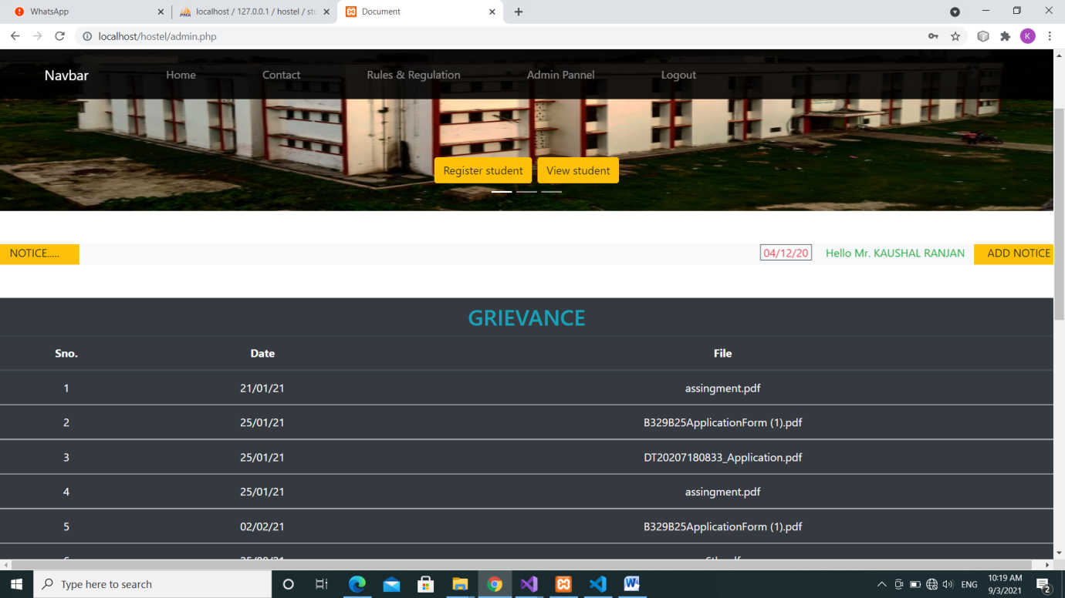

**4.2 INDEX.PHP**

<?php

  session_start();

  $con=mysqli_connect("localhost","root","","hostel");

  if(!$con)

  die("Server could not connected");

    if(isset($_SESSION["UserName"])){

        $sql1="select * from student where email='".$_SESSION["UserName"]."'";

        $rs1=mysqli_query($con,$sql1);

        $row1=mysqli_fetch_assoc($rs1);

    }

  include("student_head.php");

  $sql="select * from notice order by date desc, time desc limit 4";

  $rs=mysqli_query($con,$sql);

?>

<!DOCTYPE html>

<html lang="en">

<head>

    <meta charset="UTF-8">

    <meta name="viewport" content="width=device-width, initial-scale=1.0">

    <title>Document</title>

</head>

<body>

    <div class="cotainer-fluid my-5">

        <div class="row">

            <div class="col-md-1 bg-warning text-center"><span>NOTICE.....</span></div>

            <div class="col-md-10 bg-light">

                <marquee direction="left" onmouseout="this.start();" onmouseover="this.stop();">

                    <?php

                        while($row=mysqli_fetch_assoc($rs)){;

                    ?>

                    <span class="text-danger m-3 px-1 border border-dark"><?php echo $row["date"]; ?></span>

                    <a href="notice.php?filename=<?php echo $row["FileName"]; ?>" class="text-success"><?php echo $row["title"];  ?> </a>

                    <?php }; ?>

                </marquee>

            </div>

            <div class="col-md-1 bg-warning text-center"><a href="noticelist.php" class="text-body">more.....</a></div>

        </div>

    </div>

        <?php include("hostel.php"); ?>

        <?php include("foot.php"); ?>

</body>

</html>

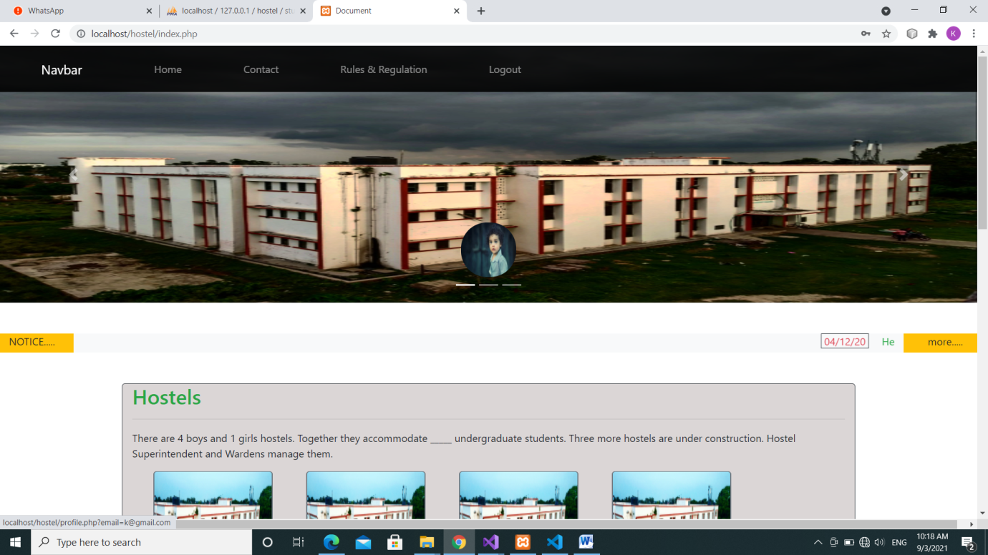

**4.3 STUDENT_HEAD.PHP**

<!DOCTYPE html>

<html lang="en">

<head>

    <meta charset="UTF-8">

    <meta name="viewport" content="width=device-width, initial-scale=1.0">

    <title>Document</title>

    <link rel="stylesheet" href="https://maxcdn.bootstrapcdn.com/bootstrap/4.5.2/css/bootstrap.min.css">

    <script src="https://ajax.googleapis.com/ajax/libs/jquery/3.5.1/jquery.min.js"></script>

    <script src="https://cdnjs.cloudflare.com/ajax/libs/popper.js/1.16.0/umd/popper.min.js"></script>

    <script src="https://maxcdn.bootstrapcdn.com/bootstrap/4.5.2/js/bootstrap.min.js"></script>

    <link rel="stylesheet" href="https://cdnjs.cloudflare.com/ajax/libs/font-awesome/4.7.0/css/font-awesome.min.css">

</head>

<body>

    <div class="container-fluid">

      <nav class="navbar navbar-expand-md navbar-dark  fixed-top" style="background-color: rgb(0, 0, 0,0.9);">

        <a class="navbar-brand  px-md-5" href="#">Navbar</a>

        <button class="navbar-toggler" type="button" data-toggle="collapse" data-target="#hover">

          <span class="navbar-toggler-icon"></span>

        </button>

        <div class="collapse navbar-collapse my-2" id="hover">

          <ul class="navbar-nav">

            <li class="nav-item">

              <a class="nav-link  px-md-5" href="index.php">Home</a>

            </li>

            <li class="nav-item">

              <a class="nav-link  px-md-5" href="#contact">Contact</a>

            </li>

            <li class="nav-item">

              <a class="nav-link  px-md-5" href="rules.php">Rules & Regulation</a>

            </li>

            <?php if(isset($_SESSION["AdminName"])){; ?>

              <li class="nav-item">

                  <a class="nav-link  px-md-5" href="admin.php">Admin Pannel</a>

              </li>

            <?php }; ?>

            <?php if(isset($_SESSION["UserName"])){; ?>

            <li class="nav-item">

              <a class="nav-link  px-md-5" href="logout.php?data=student">Logout</a>

            </li>

            <?php }else{; ?>

            <li class="nav-item">

              <a class="nav-link  px-md-5" href="login.php">Login</a>

            </li>

            <?php }; ?>

          </ul>

        </div>

      </nav>

        <div id="carouselExampleIndicators" class="row carousel slide" data-ride="carousel">

            <ol class="carousel-indicators">

              <li data-target="#carouselExampleIndicators" data-slide-to="0" class="active"></li>

              <li data-target="#carouselExampleIndicators" data-slide-to="1"></li>

              <li data-target="#carouselExampleIndicators" data-slide-to="2"></li>

            </ol>

            <div class="carousel-inner">

              <div class="carousel-item active">

                <img class="d-block w-100" src="wall_img/hostel4.jpg" alt="First slide" style="height:400px;">

                <div class="carousel-caption">

                <?php if(isset($_SESSION["UserName"])){; ?>

                    <a href="profile.php?email=<?php echo $row1["email"]; ?>"><img src="image/<?php echo $row1["img"]; ?>" width="85px" height="85px" style="border-radius:40px;"></a>

                <?php }else{ ; ?>

                  <a href="login.php" style="font-size:1rem"><i class="fa fa-user-circle-o fa-5x text-warning" aria-hidden="true"></i></a>

                <?php };?>

                </div>

              </div>

              <div class="carousel-item">

                <img class="d-block w-100" src="wall_img/h4.jpg" alt="Second slide" style="height:400px;">

                <div class="carousel-caption">

                  <?php if(isset($_SESSION["UserName"])){; ?>

                      <a href="profile.php"><img src="image/<?php echo $row1["img"]; ?>" width="85px" height="85px" style="border-radius:40px;"></a>

                  <?php }else{ ; ?>

                    <a href="login.php" style="font-size:1rem"><i class="fa fa-user-circle-o fa-5x text-warning" aria-hidden="true"></i></a>

                  <?php };?>

                </div>

              </div>

              <div class="carousel-item">

                <img class="d-block w-100" src="wall_img/p2.webp" alt="Third slide" style="height:400px;">

                <div class="carousel-caption">

                  <?php if(isset($_SESSION["UserName"])){; ?>

                      <a href="profile.php"><img src="image/<?php echo $row1["img"]; ?>" width="85px" height="85px" style="border-radius:40px;"></a>

                  <?php }else{ ; ?>

                    <a href="login.php" style="font-size:1rem"><i class="fa fa-user-circle-o fa-5x text-warning" aria-hidden="true"></i></a>

                  <?php };?>

                </div>

              </div>

            </div>

            <a class="carousel-control-prev" href="#carouselExampleIndicators" role="button" data-slide="prev">

              <span class="carousel-control-prev-icon" aria-hidden="true"></span>

              <span class="sr-only">Previous</span>

            </a>

            <a class="carousel-control-next" href="#carouselExampleIndicators" role="button" data-slide="next">

              <span class="carousel-control-next-icon" aria-hidden="true"></span>

              <span class="sr-only">Next</span>

            </a>

          </div>

    </div>

</body>

</html>

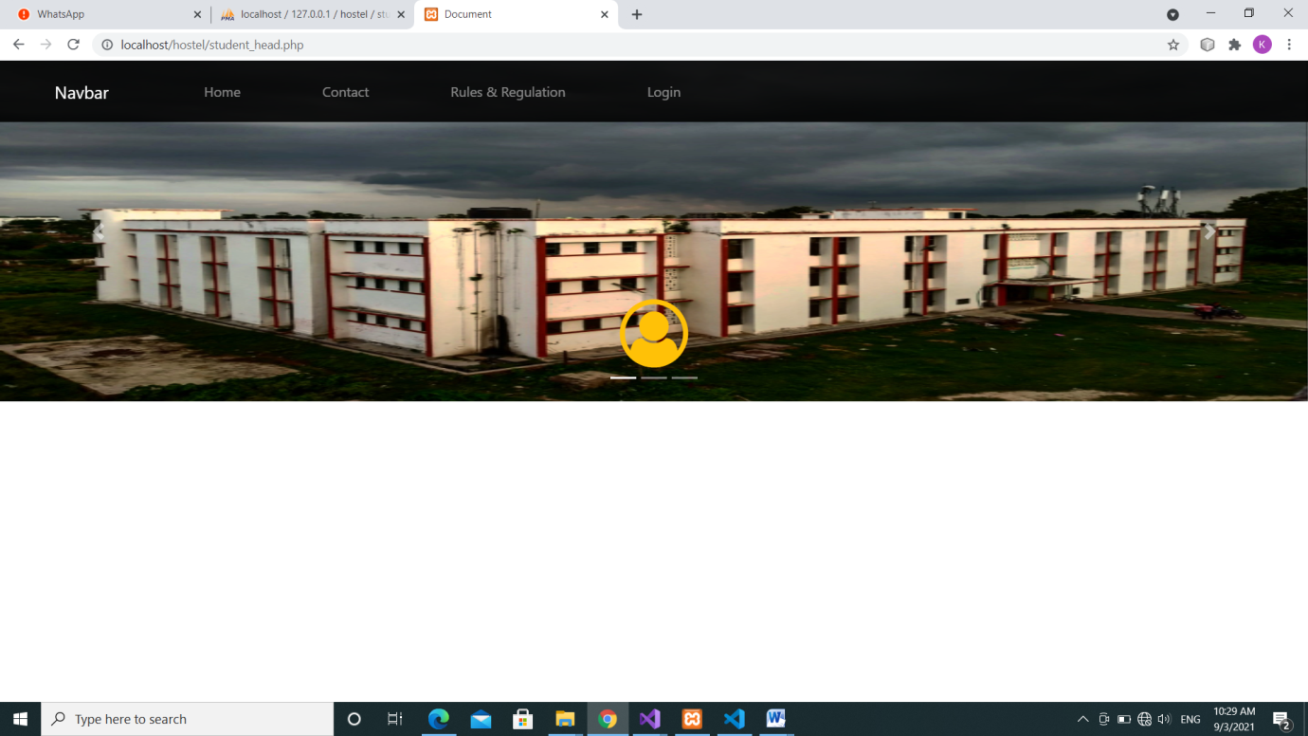

**4.4 LOGIN.PHP**

<?php

    session_start();

    include("navbar.php");

    $error=0;

    $con=mysqli_connect("localhost","root","","hostel");

    if(!$con)

    die("Server could not connected");

    if(isset($_SESSION["UserName"]))

    {

       $sql="select * from student WHERE email='".$_SESSION["UserName"]."'";

       $rs=mysqli_query($con,$sql);

       $row=mysqli_fetch_assoc($rs);

       $email=$row["email"];

       $name=$row["name"];

    }

    if(isset($_POST["login"])){

        $email=$_POST["email"];

        $password=$_POST["password"];

        $sql="select * from student WHERE email='".$email."'";

        $rs=mysqli_query($con,$sql);

        $row=mysqli_fetch_assoc($rs);

        if($row["password"]==$password)

        {

            $_SESSION["UserName"]=$email;

        header("location:index.php");

        }

        else

            $error=1;

    }

    if(isset($_POST["admin_login"])){

        $email=$_POST["email"];

        $password=$_POST["password"];

        $sql="select * from admin WHERE email='".$email."'";

        $rs=mysqli_query($con,$sql);

        $row=mysqli_fetch_assoc($rs);

        if($row["password"]==$password)

        {

            $_SESSION["AdminName"]=$email;

        header("location:admin.php");

        }

        else

            $error=1;

    }

?>

<!DOCTYPE html>

<html lang="en">

<head>

    <meta charset="UTF-8">

    <meta name="viewport" content="width=device-width, initial-scale=1.0">

    <title>Document</title>

    <script src="login.js"></script>

    <link rel="stylesheet" href="https://maxcdn.bootstrapcdn.com/bootstrap/4.5.2/css/bootstrap.min.css">

    <script src="https://ajax.googleapis.com/ajax/libs/jquery/3.5.1/jquery.min.js"></script>

    <script src="https://cdnjs.cloudflare.com/ajax/libs/popper.js/1.16.0/umd/popper.min.js"></script>

    <script src="https://maxcdn.bootstrapcdn.com/bootstrap/4.5.2/js/bootstrap.min.js"></script>

</head>

<body style="background-image:url('wall_img/h4.jpg'); background-repeat:no-repeat;  background-size: 100% 100%">

    <div class="container-fluid">

        <div class="row" style="margin:120px 0px 85px;">

            <div class="col-md-4 col-sm-12 border mx-auto" style="background-color: black; opacity:0.9 ">

                <div class=" btn-group d-flex" style="margin: 50px 0px;">

                    <button type="button" class="btn btn-default text-white" id="student" style="background-color: orange; border-radius: 15px 0px 0px 15px;"

                        onclick="student();">STUDENT</button>

                    <button type="button" class="btn btn-default text-white" id="admin" style="background-color: green; border-radius: 0px 15px 15px 0px;"

                        onclick="admin();">ADMIN</button>

                </div>

                <h3 id="head" class="text-warning text-center my-5">

                    Login as Student...

                </h3>

                <form action="<?php $_PHP_SELF ?>" method="post">

                    <div class="input-group my-5">

                      <div class="input-group-prepend">

                        <span class="input-group-text bg-transparent text-white border-right-0"><i class="fa fa-user"></i></span>

                      </div>

                      <input type="email" name="email" id="email" class="form-control bg-transparent text-white border-left-0" placeholder="Email" required>

                    </div>

                    <div class="input-group my-5">

                        <div class="input-group-prepend">

                            <span class="input-group-text bg-transparent text-white border-right-0"><i class="fa fa-lock "></i></span>

                        </div>

                        <input type="password" id="password" name="password" class="form-control bg-transparent text-white border-left-0 border-right-0" placeholder="Password" required>

                        <div class="input-group-append">

                            <span class="input-group-text bg-transparent text-white border-left-0" onclick="show();">

                                <i id="eye" class="fa fa-eye"></i>

                            </span>

                        </div>

                    </div>

                    <div>

                        <input type="submit" name="login" id="login" value="Login as Student" class="btn btn-primary text-white form-control my-5">

                    </div>

                    <div class="text-center mb-5">

                        <a id="pass" href="#?data=student">Forget password ?</a>&nbsp;&nbsp;&nbsp;&nbsp;

                        <a id="acc" href="#?data=student">Reset password</a>

                    </div>

                </form>

                  <?php

                    if($error==1){

                        echo"<div class='row'>

                        <p class='mx-auto text-danger' style='font-size:20px;'>User name or password is incorrect...</p>";

                    }?>

            </div>

        </div>

    </div>

</body>

</html>

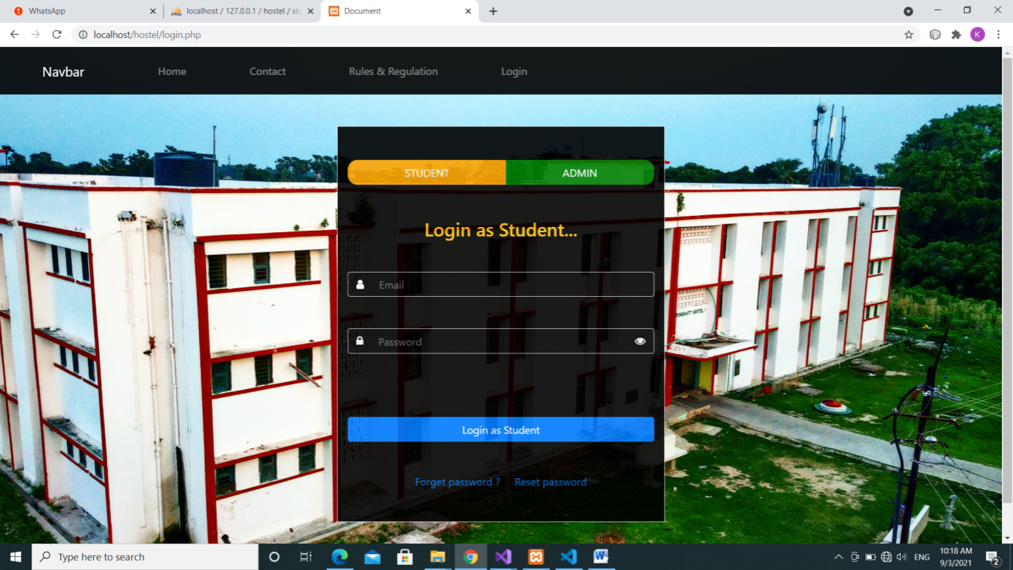

**4.5 ADMIN_HEAD.PHP**

<!DOCTYPE html>

<html lang="en">

<head>

    <meta charset="UTF-8">

    <meta name="viewport" content="width=device-width, initial-scale=1.0">

    <title>Document</title>

    <link rel="stylesheet" href="https://maxcdn.bootstrapcdn.com/bootstrap/4.5.2/css/bootstrap.min.css">

    <script src="https://ajax.googleapis.com/ajax/libs/jquery/3.5.1/jquery.min.js"></script>

    <script src="https://cdnjs.cloudflare.com/ajax/libs/popper.js/1.16.0/umd/popper.min.js"></script>

    <script src="https://maxcdn.bootstrapcdn.com/bootstrap/4.5.2/js/bootstrap.min.js"></script>

</head>

<body>

    <div class="container-fluid">

      <nav class="navbar navbar-expand-md navbar-dark  fixed-top" style="background-color: rgb(0, 0, 0,0.9);">

        <a class="navbar-brand  px-md-5" href="#">Navbar</a>

        <button class="navbar-toggler" type="button" data-toggle="collapse" data-target="#hover">

          <span class="navbar-toggler-icon"></span>

        </button>

        <div class="collapse navbar-collapse my-2" id="hover">

          <ul class="navbar-nav">

            <li class="nav-item">

              <a class="nav-link  px-md-5" href="index.php">Home</a>

            </li>

            <li class="nav-item">

              <a class="nav-link  px-md-5" href="#">Contact</a>

            </li>

            <li class="nav-item">

               <a class="nav-link  px-md-5" href="rules.php">Rules & Regulation</a>

               </li>

            <li class="nav-item">

              <a class="nav-link  px-md-5" href="admin.php">Admin Pannel</a>

            </li>

                <?php if(isset($_SESSION["AdminName"])){; ?>

                    <li class="nav-item">

                        <a class="nav-link  px-md-5" href="logout.php?data=admin">Logout</a>

                    </li>

                    <?php }else{; ?>

                    <li class="nav-item">

                        <a class="nav-link  px-md-5" href="login.php">Login</a>

                    </li>

                <?php }; ?>

          </ul>

        </div>

      </nav>

        <div id="carouselExampleIndicators" class="row carousel slide" data-ride="carousel">

            <ol class="carousel-indicators">

              <li data-target="#carouselExampleIndicators" data-slide-to="0" class="active"></li>

              <li data-target="#carouselExampleIndicators" data-slide-to="1"></li>

              <li data-target="#carouselExampleIndicators" data-slide-to="2"></li>

            </ol>

            <div class="carousel-inner">

              <div class="carousel-item active">

                <img class="d-block w-100" src="wall_img/hostel4.jpg" alt="First slide" style="height:400px;">

                <div class=" row carousel-caption">

                    <div class="col-md-4 mx-auto">

                      <div class="row">

                        <a href="register.php" class="btn btn-warning ml-auto mr-2">Register student</a>

                        <a href="view.php" class="btn btn-warning mr-auto">View student</a>

                      </div>

                    </div>

                </div>

              </div>

              <div class="carousel-item">

                <img class="d-block w-100" src="wall_img/h4.jpg" alt="Second slide" style="height:400px;">

                <div class=" row carousel-caption">

                    <div class="col-md-4 mx-auto">

                      <div class="row">

                        <a href="register.php" class="btn btn-warning ml-auto mr-2">Register student</a>

                        <a href="view.php" class="btn btn-warning mr-auto">View student</a>

                      </div>

                    </div>

                </div>

              </div>

              <div class="carousel-item">

                <img class="d-block w-100" src="wall_img/p2.webp" alt="Third slide" style="height:400px;">

                <div class=" row carousel-caption">

                    <div class="col-md-4 mx-auto">

                      <div class="row">

                        <a href="register.php" class="btn btn-warning ml-auto mr-2">Register student</a>

                        <a href="view.php" class="btn btn-warning mr-auto">View student</a>

                      </div>

                    </div>

                </div>

              </div>

            </div>

            <a class="carousel-control-prev" href="#carouselExampleIndicators" role="button" data-slide="prev">

              <span class="carousel-control-prev-icon" aria-hidden="true"></span>

              <span class="sr-only">Previous</span>

            </a>

            <a class="carousel-control-next" href="#carouselExampleIndicators" role="button" data-slide="next">

              <span class="carousel-control-next-icon" aria-hidden="true"></span>

              <span class="sr-only">Next</span>

            </a>

          </div>

    </div>

</body>

</html>

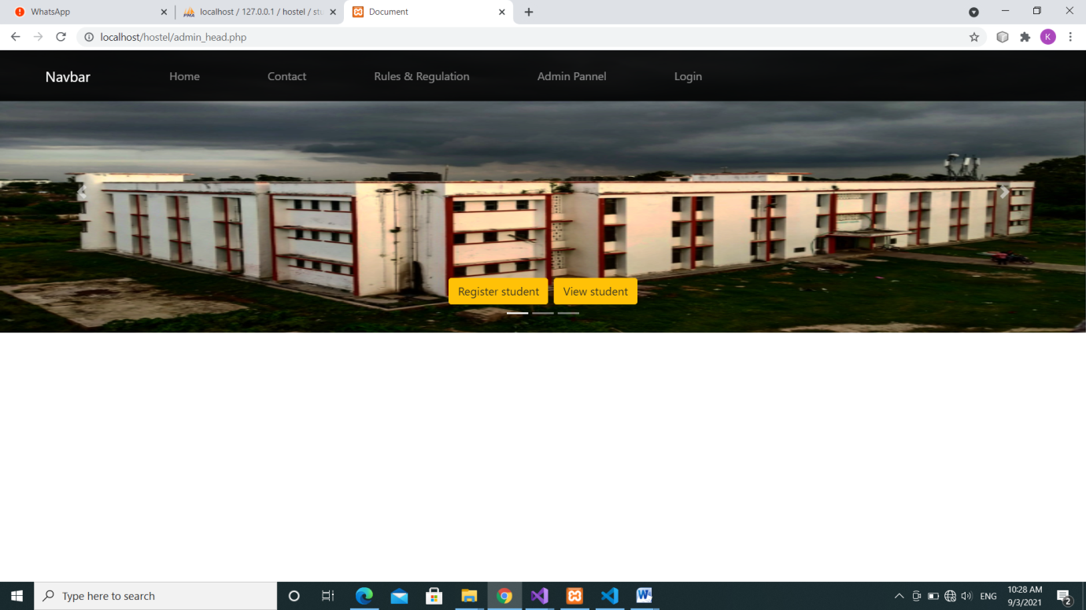

**4.6 PROFILE.PHP**

<?php

session_start();

if (isset($_SESSION["UserName"])) {

    include("navbar.php");

    $con = mysqli_connect("localhost", "root", "", "hostel");

    if (!$con)

        die("Server could not connected");

    $sql = "select * from student where email='" . $_GET["email"] . "'";

    $rs = mysqli_query($con, $sql);

    $row = mysqli_fetch_assoc($rs);

    $sql1 = "select * from hostel_detail where email='" . $_GET["email"] . "'";

    $rs1 = mysqli_query($con, $sql1);

    $row1 = mysqli_fetch_assoc($rs1);

    $sql2 = "select * from meal_detail where email='" . $_GET["email"] . "'";

    $rs2 = mysqli_query($con, $sql2);

    $row2 = mysqli_fetch_assoc($rs2);

}

?>

<!DOCTYPE html>

<html lang="en">

<head>

    <meta charset="UTF-8">

    <meta name="viewport" content="width=device-width, initial-scale=1.0">

    <title>Document</title>

</head>

<body>

    <div class="container-fluid" style="margin-top:72px; background-color: rgb(219, 214, 214)">

        <div class="row pt-3">

            <div class="col-md-3">

                <img src="image/<?php echo $row["img"]; ?>" width="200px" height="200px" alt="" style="border-radius:25px;">

            </div>

            <div class="col-md-8">

                <div class="row mt-4">

                    <div class="col-md-3 ">

                        <h6>Name : </h6>

                    </div>

                    <div class="col-md-4 "><?php echo $row["name"]; ?></div>

                </div>

                <div class="row">

                    <div class="col-md-3 r">

                        <h6>Registration Number : </h6>

                    </div>

                    <div class="col-md-4 "><?php echo $row["reg_no"]; ?></div>

                </div>

                <div class="row">

                    <div class="col-md-3 ">

                        <h6> Branch : </h6>

                    </div>

                    <div class="col-md-4 "><?php echo $row["branch"]; ?></div>

                </div>

                <div class="row">

                    <div class="col-md-3 ">

                        <h6> Contact Number : </h6>

                    </div>

                    <div class="col-md-4 "><?php echo $row["mobile"]; ?></div>

                </div>

                <div class="row mt-3">

                    <?php if($row1["remainingamount"]<1000){?>

                        <marquee behavior="alternate" height="40" width="75%" direction="left" class="bg-danger text-light rounded-lg"><h4>Your mess fund is to low refil as soon as possible</h4></marquee>

                    <?php }else{ ?>

                        <marquee behavior="alternate" height="40" width="75%" direction="left" class="bg-success text-light rounded-lg"><h4>Your current mess fund is <?Php echo $row1["remainingamount"];?> </h4></marquee>

                    <?php } ?>

                </div>

            </div>

        </div>

        <hr class="mb-5">

        <h5 class="text-danger">Personal Details</h5>

        <hr class="mb-2">

        <div class="row">

            <div class="col-md-3 ml-5">Name : </div>

            <div class="col-md-5 ml-5"><?php echo $row["name"]; ?></div>

        </div>

        <div class="row">

            <div class="col-md-3 ml-5">Mother Name : </div>

            <div class="col-md-5 ml-5"><?php echo $row["mname"]; ?></div>

        </div>

        <div class="row">

            <div class="col-md-3 ml-5">Father Name : </div>

            <div class="col-md-5 ml-5"><?php echo $row["fname"]; ?></div>

        </div>

        <div class="row">

            <div class="col-md-3 ml-5">Mobile no. : </div>

            <div class="col-md-5 ml-5"><?php echo $row["mobile"]; ?></div>

        </div>

        <div class="row">

            <div class="col-md-3 ml-5">Email : </div>

            <div class="col-md-5 ml-5"><?php echo $row["email"]; ?></div>

        </div>

        <div class="row">

            <div class="col-md-3 ml-5">Emergency Contact : </div>

            <div class="col-md-5 ml-5"><?php echo $row["econtact"]; ?></div>

        </div>

        <div class="row">

            <div class="col-md-3 ml-5">Corresponding Address : </div>

            <div class="col-md-5 ml-5"><?php echo $row["coaddr"]; ?></div>

        </div>

        <div class="row">

            <div class="col-md-3 ml-5">Permanent Address : </div>

            <div class="col-md-5 ml-5"><?php echo $row["praddr"]; ?></div>

        </div>

        <hr class="mb-3">

        <h5 class="text-danger">Hostel Details</h5>

        <hr class="mb-3">

        <div class="row">

            <div class="col-md-3 ml-5">Hostel Name :</div>

            <div class="col-md-5 ml-5"><?php echo $row1["hostelname"]; ?></div>

        </div>

        <div class="row">

            <div class="col-md-3 ml-5">Room no. :</div>

            <div class="col-md-5 ml-5"><?php echo $row1["room"]; ?></div>

        </div>

        <div class="row">

            <div class="col-md-3 ml-5">Amount Paid For Accomodation :</div>

            <div class="col-md-5 ml-5"><?php echo $row1["hostelamount"]; ?></div>

        </div>

        <div class="row">

            <div class="col-md-3 ml-5">Amount Paid For Meal :</div>

            <div class="col-md-5 ml-5"><?php echo $row1["mealamount"]; ?></div>

        </div>

        <div class="row">

            <div class="col-md-3 ml-5">Amount Consumed :</div>

            <div class="col-md-5 ml-5"><?php echo $row1["amountconsumed"]; ?></div>

        </div>

        <div class="row">

            <div class="col-md-3 ml-5">Remaining Amount :</div>

            <div class="col-md-5 ml-5"><?php echo $row1["remainingamount"]; ?></div>

        </div>

        <hr class="mb-3">

        <h5 class="text-danger">Meal Details</h5>

        <hr class="mb-3">

        <div class="row">

            <div class="col-md-3 ml-5">January :</div>

            <div class="col-md-5 ml-5"><?php echo $row2["jan"]; ?></div>

        </div>

        <div class="row">

            <div class="col-md-3 ml-5">February :</div>

            <div class="col-md-5 ml-5"><?php echo $row2["feb"]; ?></div>

        </div>

        <div class="row">

            <div class="col-md-3 ml-5">March:</div>

            <div class="col-md-5 ml-5"><?php echo $row2["mar"]; ?></div>

        </div>

        <div class="row">

            <div class="col-md-3 ml-5">April :</div>

            <div class="col-md-5 ml-5"><?php echo $row2["apr"]; ?></div>

        </div>

        <div class="row">

            <div class="col-md-3 ml-5">May :</div>

            <div class="col-md-5 ml-5"><?php echo $row2["may"]; ?></div>

        </div>

        <div class="row">

            <div class="col-md-3 ml-5">June :</div>

            <div class="col-md-5 ml-5"><?php echo $row2["june"]; ?></div>

        </div>

        <div class="row">

            <div class="col-md-3 ml-5">July :</div>

            <div class="col-md-5 ml-5"><?php echo $row2["july"]; ?></div>

        </div>

        <div class="row">

            <div class="col-md-3 ml-5">August :</div>

            <div class="col-md-5 ml-5"><?php echo $row2["aug"]; ?></div>

        </div>

        <div class="row">

            <div class="col-md-3 ml-5">September :</div>

            <div class="col-md-5 ml-5"><?php echo $row2["sep"]; ?></div>

        </div>

        <div class="row">

            <div class="col-md-3 ml-5">October :</div>

            <div class="col-md-5 ml-5"><?php echo $row2["oct"]; ?></div>

        </div>

        <div class="row">

            <div class="col-md-3 ml-5">November :</div>

            <div class="col-md-5 ml-5"><?php echo $row2["nov"]; ?></div>

        </div>

        <div class="row">

            <div class="col-md-3 ml-5">December :</div>

            <div class="col-md-5 ml-5"><?php echo $row2["dece"]; ?></div>

        </div>

        <hr class="mb-3">

    </div>

    <?php include("foot.php"); ?>

</body>

</html>

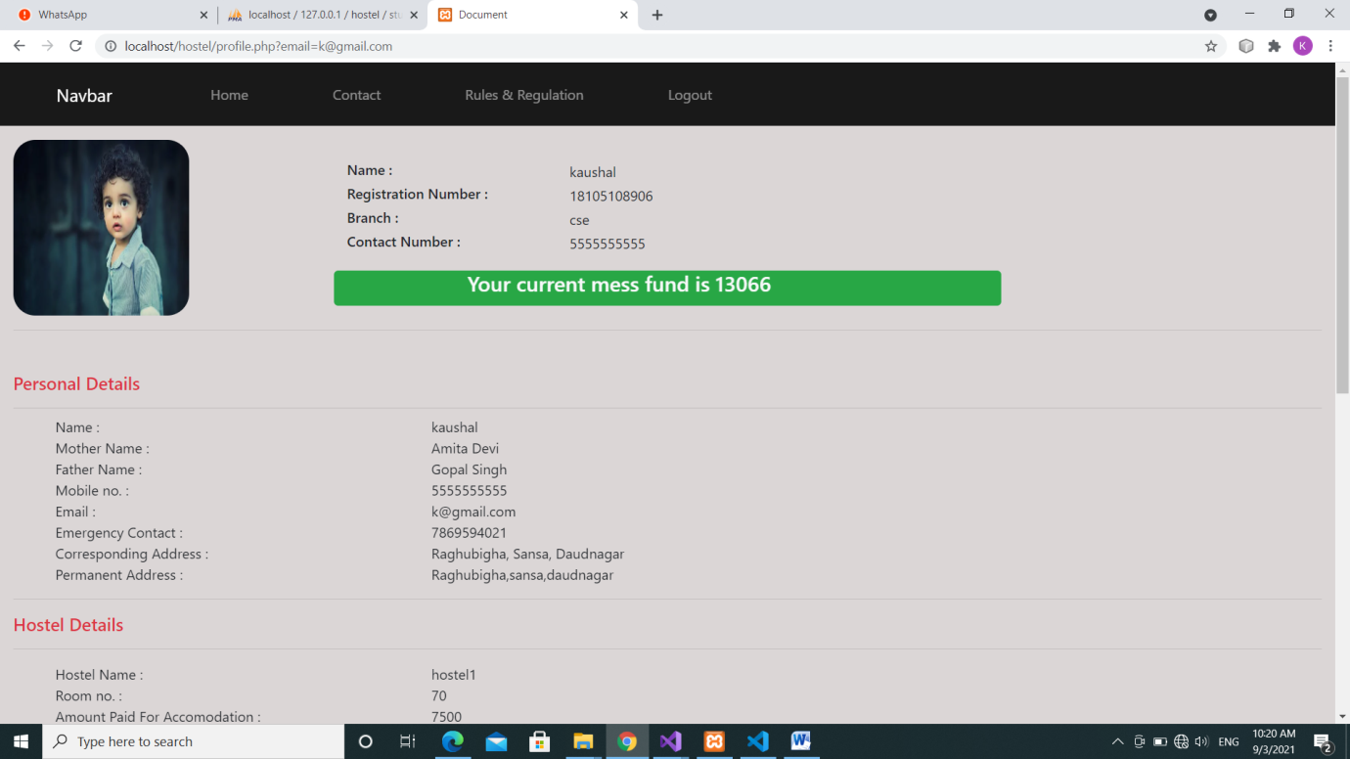

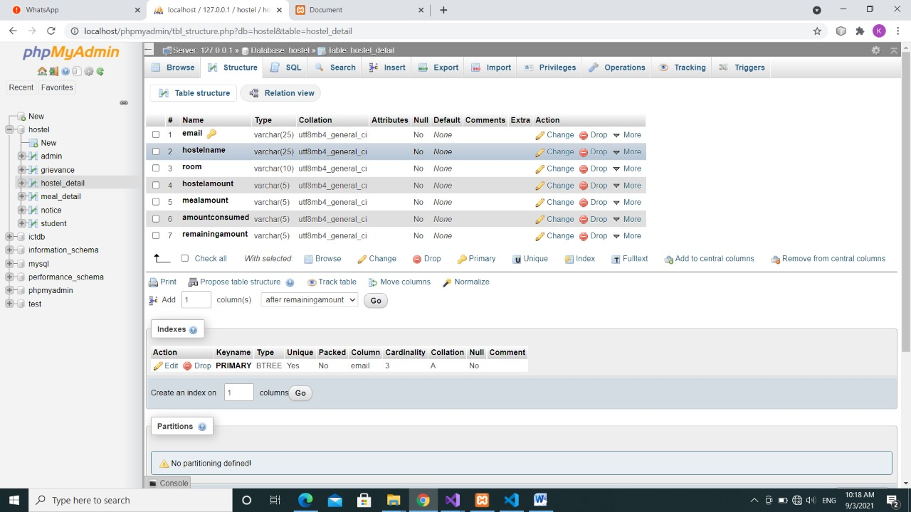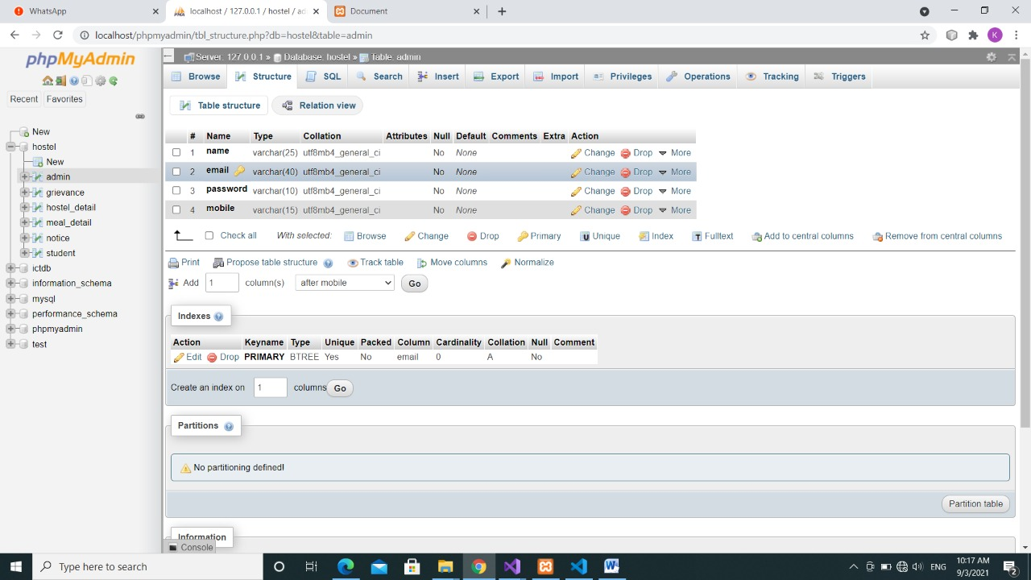

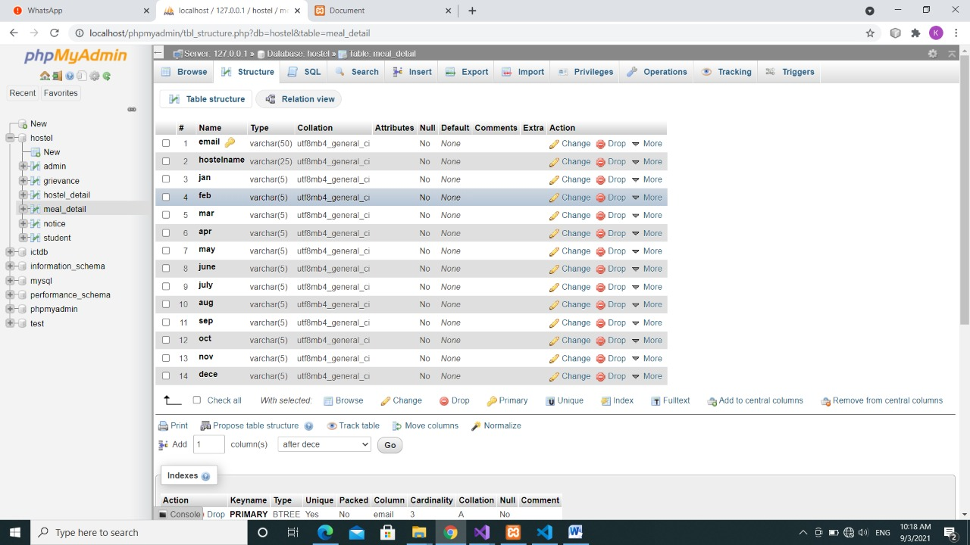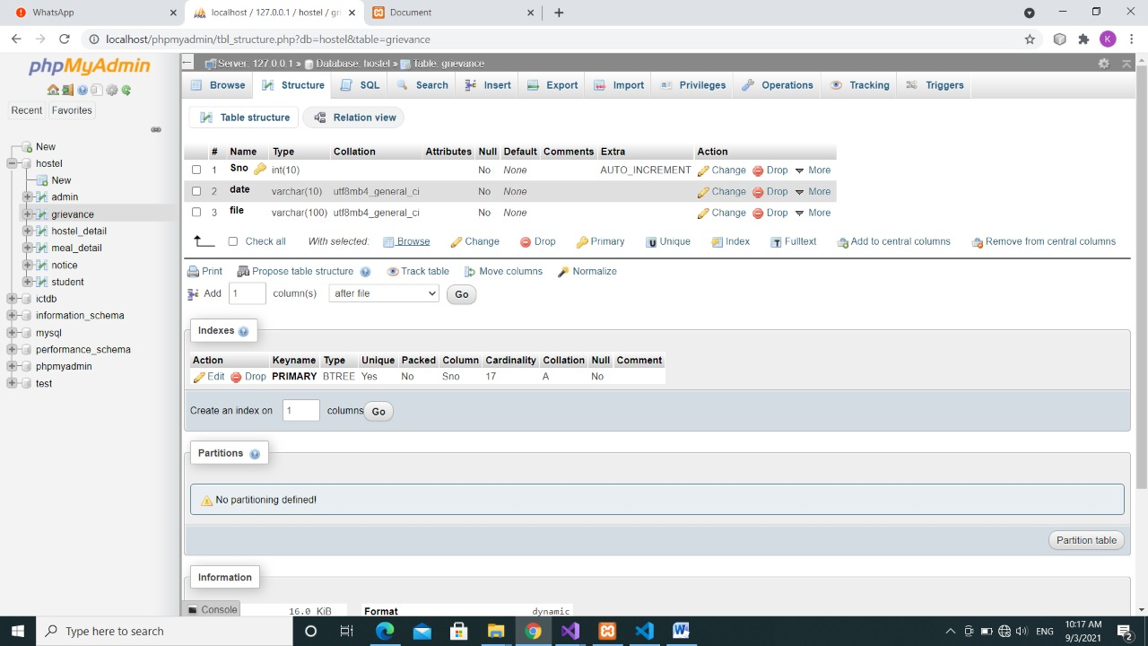

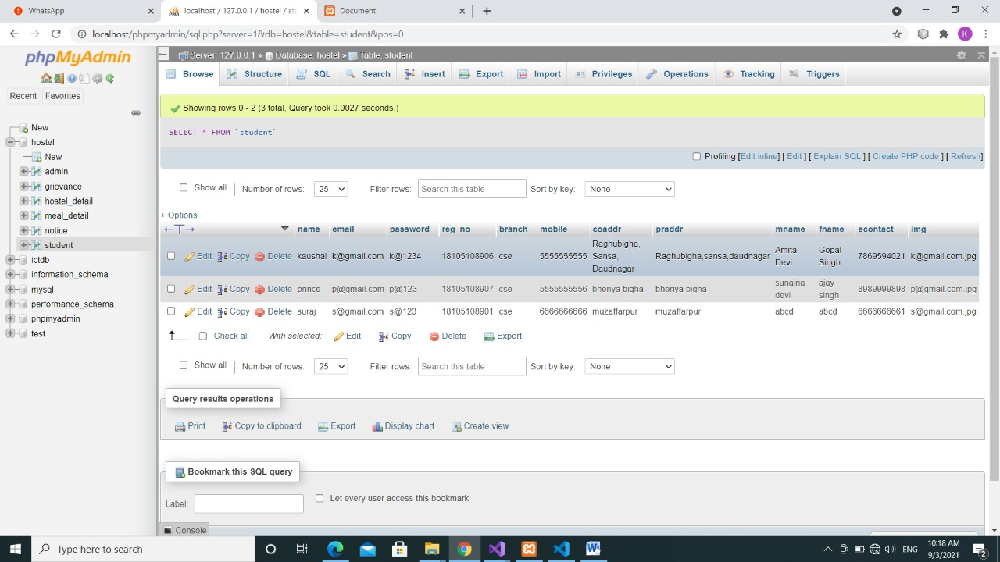

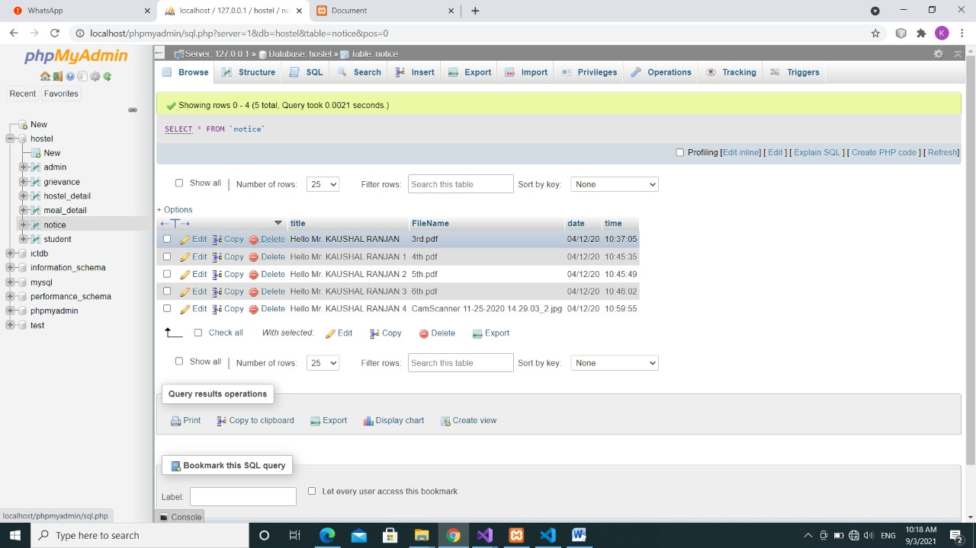

1. **CONCLUSION**

To conclude the description about the project: The project developed using PHP and MySQL is based on the requirement specification of the user and the analysis of the existing system, with flexibility for future enhancement.

The expanded functionality of today’s software requires an appropriate approach towards software development. This hostel management software is designed for people who want to manage various activities in the hostel. For the past few years the numbers of educational institutions are increasing rapidly. Thereby the numbers of hostels are also increasing for the accommodation of the students studying in this institution. And hence there is a lot of strain on the person who are running the hostel and software’s are not usually used in this context. This particular project deals with the problems on managing a hostel and avoids the problems which occur when carried manually.

Identification of the drawbacks of the existing system leads to the designing of computerized system that will be compatible to the existing system with the system which is more user friendly and more GUI oriented.

THANK YOU